## Lab 1. [Building a time tracking flow](https://preview.flow.microsoft.com/en-us/galleries/public/templates/3eb0ac6101304a568ee524fc23d54cbc/track-your-time-in-an-excel-online-business-spreadsheet/)

**Author:** Serge Luca aka “Doctor Flow”

**Learning objectives:** Building a Flow, hello world, button, time.

**Duration:** 30 minutes

**Scenario:** When a user pushes a button, the current time and the current location will be saved in an Excel document stored in OneDrive for Business.

#### Task 1.1: Build an instant flow from blank

1. Navigate to **OneDrive** (for Business), and create a new Excel workbook:
   1. Click **New** and select **Excel workbook**.

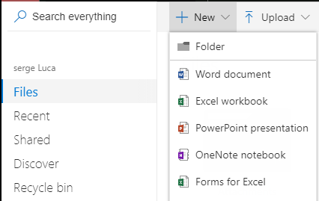

* 1. Create **4** columns, **where**, **who**, **when, comment**.

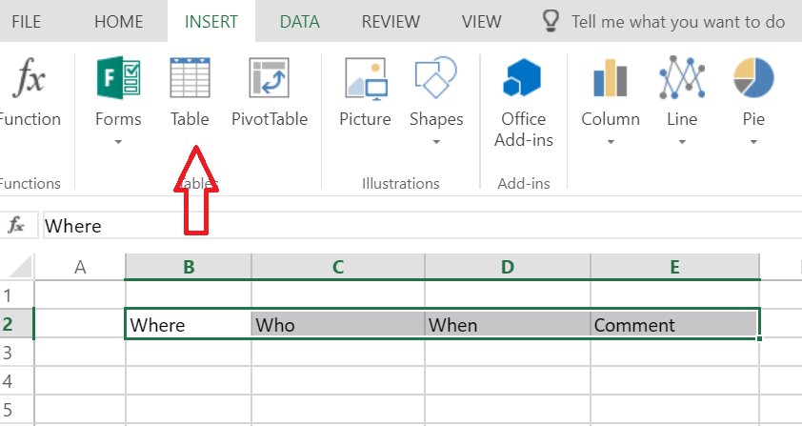

* 1. Format as a table (check the box, has headers)

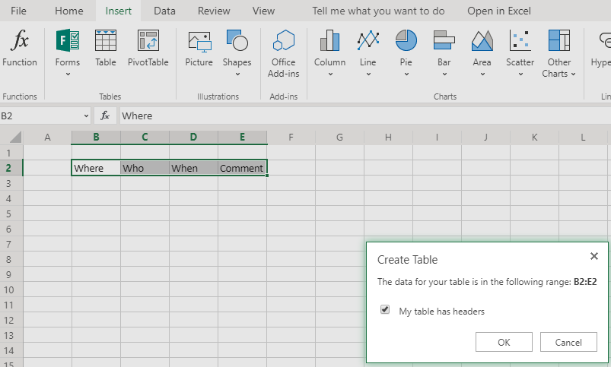

* 1. Save the file (**File** > **Save as** - **Rename**) with name, **Timesheet.xlsx**.

1. Create a flow named **Track Time** using the following steps:
   1. Navigate to [**Flow.microsoft.com**](https://flow.microsoft.com) and if requested, sign-in.
   2. Select **My flows**

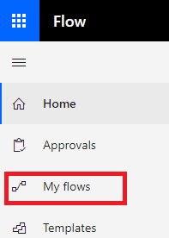

* 1. Select **New > Instant from blank**.

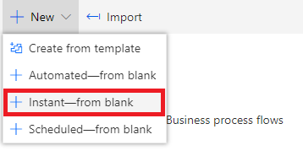

* 1. On the **Build an instant flow** dialog, in the **Flow name** text box, type, **Track time** and select the trigger **Manually trigger a flow**.

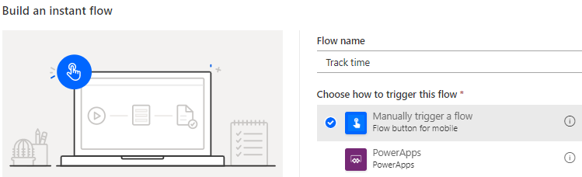

* 1. Click **Create**.

A flow is generated with the trigger, Manually trigger a flow.

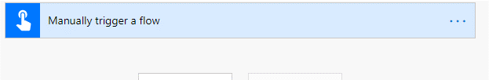

**Note:** This trigger will start the flow by pressing a button. The button is also visible in the Flow mobile app, including in the home screen of a smartphone. If needed, a form can be displayed when the user selects the button. In any case, default information such as, the current user’s coordinates (Latitude & Longitude) and current time are captured automatically from the device by flow when the button is pressed.

1. In the flow add an action to create a row in the Excel table by completing the following steps:
   1. Click **New step:**

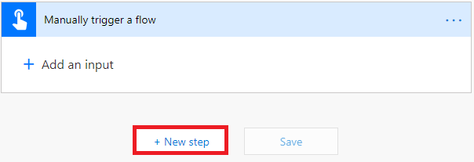

* 1. In the **Choose an action** text box, type **Excel** and select **Excel Online (Business)** connector.   
     **DO NOT** select Excel Online OneDrive; be careful here, many users select the wrong connector.

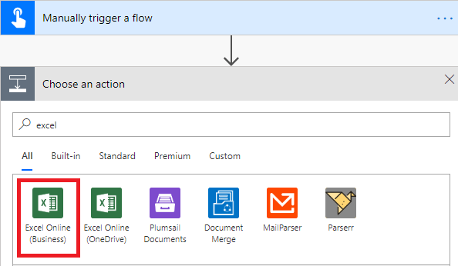

* 1. Select the **Excel Online (Business) Add a row into a table** action.

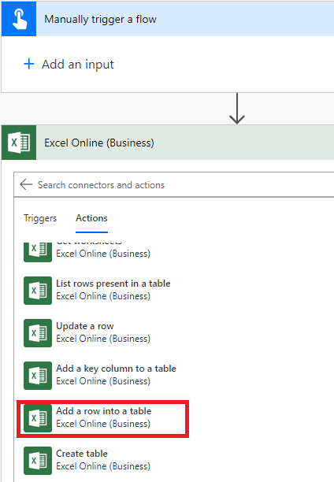

Your flow should look similar to the following screenshot:

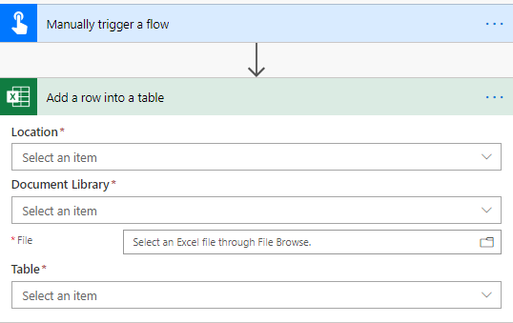

1. Configure the action, add a row into a table, input properties to add the current user’s location and time stamp to the spreadsheet, using the following steps:
   1. From the **Location** drop down select **OneDrive for Business**, and in the **Document Library** drop down select **OneDrive**.
   2. To the far right of the **File** text box, select the folder icon, browse and select the spreadsheet you created earlier, **Timesheet.xlsx**.
2. When the spreadsheet has been selected, the fields will automatically be visible:

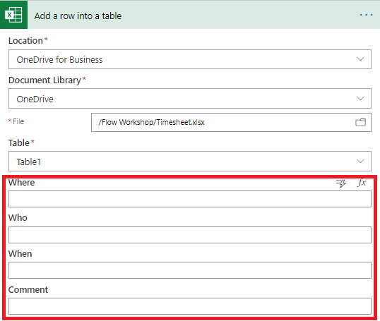

1. In this step we are going to map the fields to the real values
   1. Click the button **Add a dynamic value**

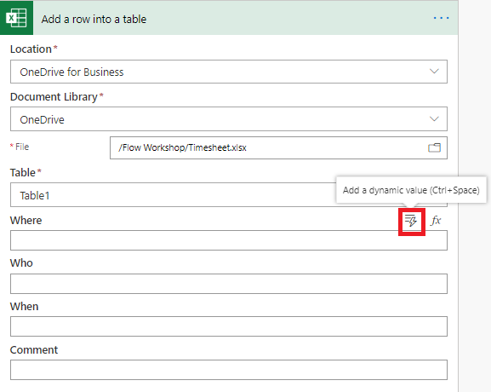

to select the properties as follows:



|  |  |
| --- | --- |
| **Where** | **Full address** |
| **Who** | **User name** |
| **When** | **Timestamp** |

Your Add a row into a table action should look similar to the following screenshot:

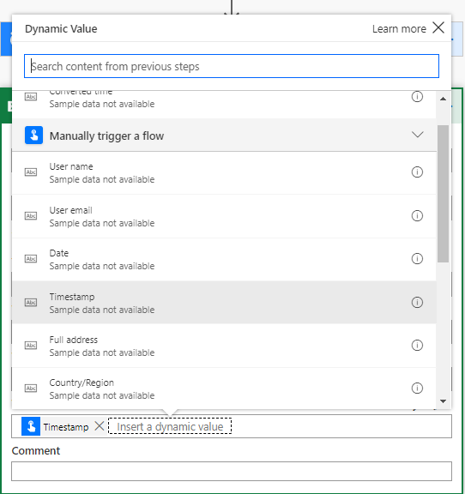

1. In the upper right corner, select **Save**.



1. Run the Flow, using the following steps:
   1. Click the back arrow to return to the flow page
   2. Click the three dots to the left of **More** and then click **Run now** (you could also use the **Test** button).

**Note:** If needed, click **Allow** to allow the flow to access your device to obtain your location.

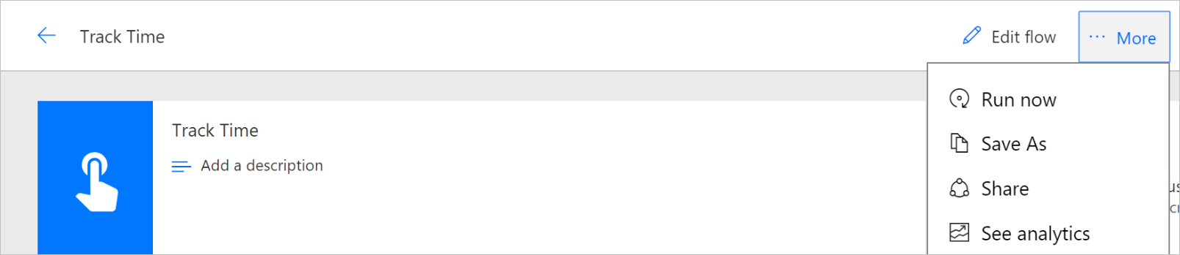

* 1. Ensure the flow ran successfully by checking your Excel sheet. You should see a new row with the requested information



**Note:** You might have to refresh the spreadsheet to see the updated values.

#### Task 1.2: Convert the timestamp to a more user-friendly date/time format

1. By default, Microsoft Automate uses UTC as its default time zone. Use the following steps to display the timestamp that matches your time zone.
   1. Hover over the arrow joining the Manual trigger and the Excel action and click the **+** icon that appears, and click **Add an action**.
   2. In the **Search** text box, type **convert** and then select **Convert time zone**.
   3. In the **Base time** property, select the trigger’s output property, **Timestamp**.
   4. Use the drop-down list to select an appropriate time zone for the **Source time zone** and **Destination time zone** properties.
   5. In the **Format** **string** property, scroll to the bottom of the drop-down list and select **custom** and then type **dd/MM/yyyy-T-hh:mm:ss.**Notice there are several predefined Date & Time formats. Your Convert time zone action should look similar to the following screenshot.

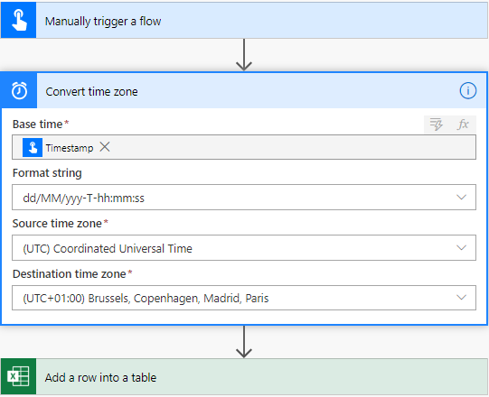

1. Update the **Add a row into a table** action with the **Converted time** value:

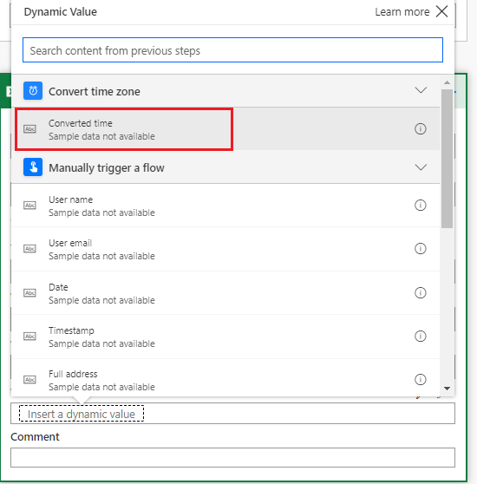

1. Save the Flow, rerun it, and check your Excel sheet:

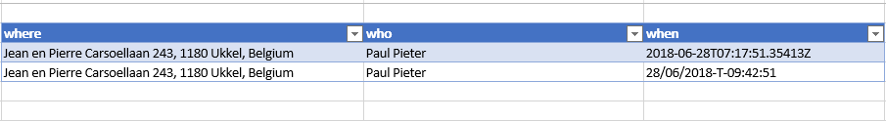

#### Task 1.3: Optional, interact with your flow on your mobile

**Note:** This task has been tested using an Android phone; the look and feel might be a little bit different on iOS.

1. Prepare the mobile app on your phone.
   1. 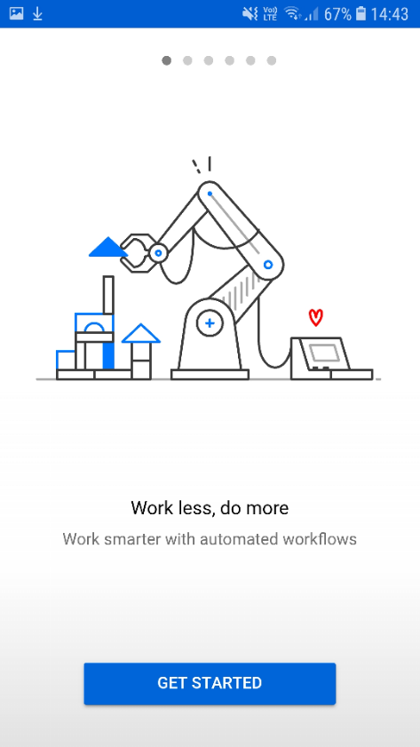If you do not already have the mobile app on your phone download the **Microsoft Automate** mobile application from the store (Android/iOS).
2. Complete one of the following:

If your app is signed into a tenant other than the one you are using for the labs, sign out and then sign in using the credentials for the tenant you are using for the labs.

Or

* 1. If you have never used the mobile app before, click **Get started**
  2. Sign in with your account provided by the instructor.

1. Start the flow from your phone by completing the following steps:
   1. Click **Buttons**:

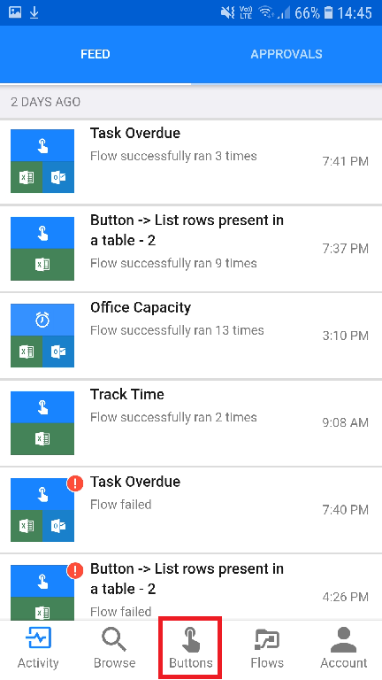

The **Track Time** button should be displayed.

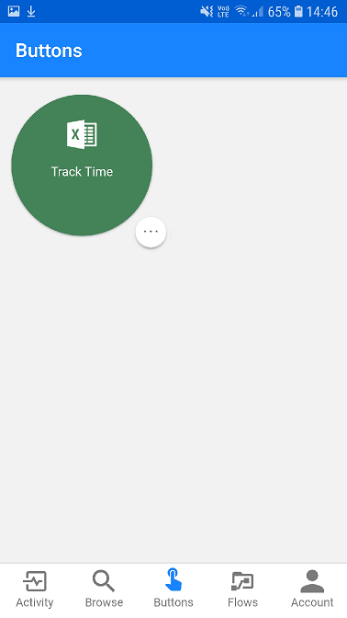

* 1. Click the **Track Time** button to execute the flow
  2. Ensure that the flow ran successfully by checking that a new line was added to the Excel spreadsheet.

#### Task 1.4: Amend the flow to update the comment field in the spreadsheet

Now you are going to get the flow to update the **comment** field within your spreadsheet:

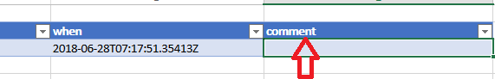

1. Add an input parameter to the flow button trigger using the following steps:
   1. Edit the Flow, click on trigger heading (**Manually trigger a Flow**) and then click **Add an input:**

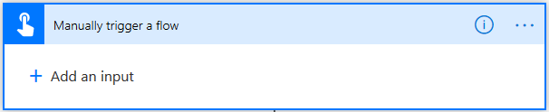

* 1. Click **Text** to add a text parameter, named input.

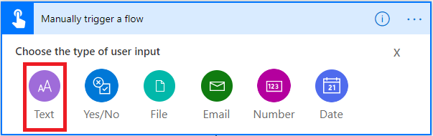

**Notice**: There are many parameter types to assist the interaction with users when they click on a Flow button. Use these data input types to improve the data integrity of the information provided by the users.

* 1. Delete **Input** and type **comment** and in the text box to the right of comment, press the space bar to use the space character as the default value:

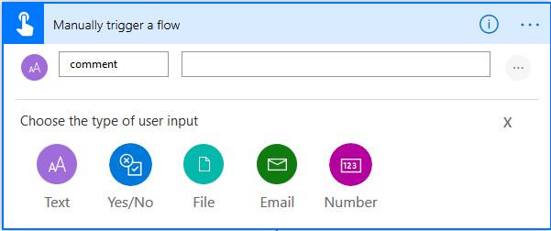

1. Modify the Excel action to update the comment value
   1. Click the action **Add row into a table**.
   2. Add a **dynamic value** to update the Excel action **comment** property with the trigger **comment** output property:

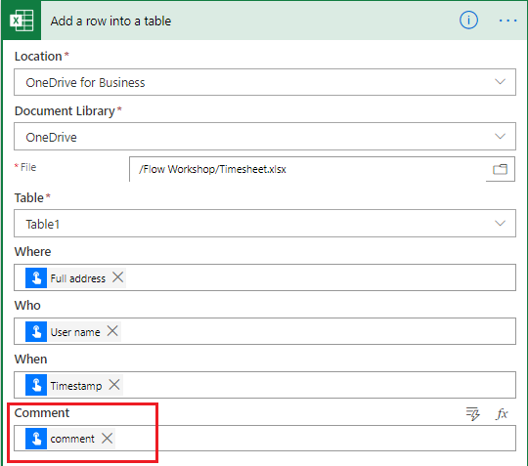

1. Save, run and check.
   1. Save the Flow and return to the flow details page.
   2. Run the Flow by clicking on **Run now** from **…More** menu. If the flow requests access to your device, click **Allow**.

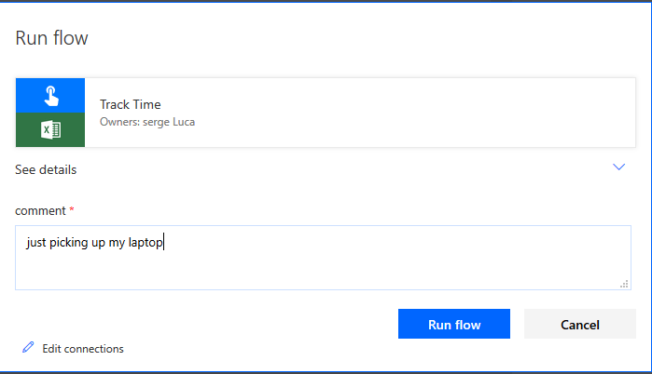

* 1. Type some text in the comment parameter in the form.
  2. If you run it from your mobile, you will see something similar to the following screenshot after the button is pushed:



1. Check the spreadsheet, and you should see a new row with your comment:

